GRADE: XI PERIODIC TEST – III DATE: 18.08.22
MARKS: 40 PHYSICS (042) TIME: 1½ Hrs
SECTION A

- The dimensional formula for ω in the relation y = A Sin ωt is
- [M° L° T ] (b) [M° L° T^{–1}] (c) [ML° T°] (d) [M° L^{–1} T^{–1}]

- Out of 4.0 and 4.00, which is more accurate
- 4.0 (b) 4.00 (c) Both are equally accurate (d) Nothing can be said

- If percentage errors in the measurement of mass and volume of an object are 2% and 3% respectively, then the percentage error in the measurement of the density of the object is :
- 1% (b) 0.66% (c) 5% (d) 6%

- The number of significant figures in 30.00 m are
- 1 (b) 2 (c) 3 (d) 4

- Acceleration of a particle changes when
- Direction of velocity changes (b) Magnitude of velocity changes (c) Both of above (d) Speed changes

- The acceleration of a moving body can be found from
- Area under velocity-time graph (b) Area under distance-time graph (c) Slope of the velocity-time graph (d) Slope of distance-time graph

- The ratio of the numerical values of the average velocity and average speed of a body is always
- Unity (b) Unity or less (c) Unity or more (d) Less than unity

- In a wire, when elongation is 2 cm energy stored is E, if it is stretched by 10 cm, then the energy stored will be
- E (b) 2E (c) 4E (d) 25E

- Longitudinal strain is possible in the case of
- Gases (b) Liquid (c) Only solids (d) Only gases and liquids
- In magnitude, hydraulic stress is equal to
- Hydraulic force (b) Hydraulic pressure (c) Restoring force (d) Hydraulic strain

SECTION B
- State the principle of homogeneity. Test the dimensional homogeneity of equation s=ut+at²/2

- Draw velocity-time graph of uniform motion and prove that the area under the velocity time graph of a particle gives the displacement of the particle in a given time.

- The position coordinate of a moving particle is given by x = 6 + 18t + 9t² (x in meters and t in seconds). What is its velocity at t = 2 sec.

- Elucidate the two types of stresses present in longitudinal stress with definition and diagrams.
SECTION C
- Define dimensional formula. Give uses of dimensional analysis. Write down the limitations of dimensional analysis.

- The length of a rod as measured in an experiment was found to be 2.48m, 2.46m, 2.49m, 2.50m and 2.48m. Find the average length, absolute error and percentage error. Express the result with error limit.

- The velocity time graph of a particle is given by
- Calculate displacement of particle from given v-t graph.
- Draw acceleration-time graph of given v-t graph.

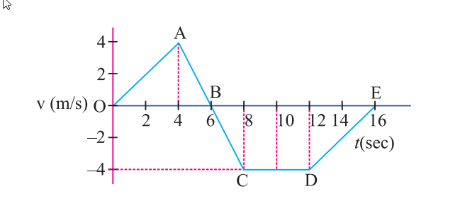

- A steel wire of length 4.7 m and cross-sectional area 3.0 x 10⁻⁵ m² stretches by the same amount as a copper wire of length 3.5 m and cross-sectional area of 4.0 x
10⁻⁵ m² under a given load. What is the ratio of the Young’s modulus of steel to that
of copper?

SECTION D
- Explain
- Absolute error and percentage error

- The acceleration of a particle in ms⁻² is given by a = 3t² + 2t + 2, where time t is in second.
If the particle starts with a velocity v = 2 ms⁻¹ at t = 0, then find the velocity at the end of 2 s.

- With the help of stress-strain curve, explain elastic limit.

- Derive the following equations of motion for an object moving with constant acceleration along a straight line using graphical method
(i) velocity time relation
(ii) Position time relation
(iii) velocity-displacement relation

